THE BRITISH CHAMBER OF COMMERCE SHANGHAI
A NIGHT OF BRITISH MAGICAL TALES
Saturday 29 May @ W Shanghai - The Bund
TICKET RESERVATION FORM & PAYMENT DETAILS
Dress Code: Fancy Dress or Black tie (* Please note this event is open to adults only)

Please complete the following to make your ball ticket reservation and return via email to
nathalie.xu@britishchambershanghai.cn
Your booking will not be confirmed until full payment has been received.
The British Chamber accepts payment in cash at our office, WeChat payment or via local bank transfer. (please see more payment details below).

Reservation
Name: |  | Company:
Mobile Number: |  | Email:
Address for ticket delivery in Chinese
No. of tickets - please state the no. you require | __________ Early-Bird tickets  members – 1,350rmb; non-members – 1,800rmb  Above Early-Bird offer is available only if you book and pay  before 1 pm, Friday 7 May 2021  __________ Tickets  members – 1,650rmb; non-members – 2,100rmb

Guest’s Information
 | First name | Last name | Special Dietary Requirements  (Please list food allergies e.g. to shellfish, gluten free, vegetarian requests below)  Deadline: 5 pm Friday 14 May

Payment Method
TOTAL AMOUNT DUE (in RMB)
How would you like to pay? | □ Cash □Bank Transfer □ WeChat pay

[METHODS OF PAYMENT]

Option 1 - In cash at the British Chamber of Commerce Shanghai office
Add: Room 1108, South Tower, M Place, 333 Chengdu Bei Lu, Shanghai
上海市静安区成都北路333号 招商局广场 南楼 1108室

Option 2 - Bank transfer to the following account
Account Name: 上海盈商荟投资咨询有限公司
Account number: 1001000109216201938
Beneficiary Bank: 中国工商银行股份有限公司上海市石门一路支行
Swift Code: ICBKCNBJSHI
- Please note that all applicable bank charges must be paid by the ticket purchaser.
- For foreign currency wiring, please contact our Finance Manager in advance for assistance and details.

Option 3 – WeChat Pay
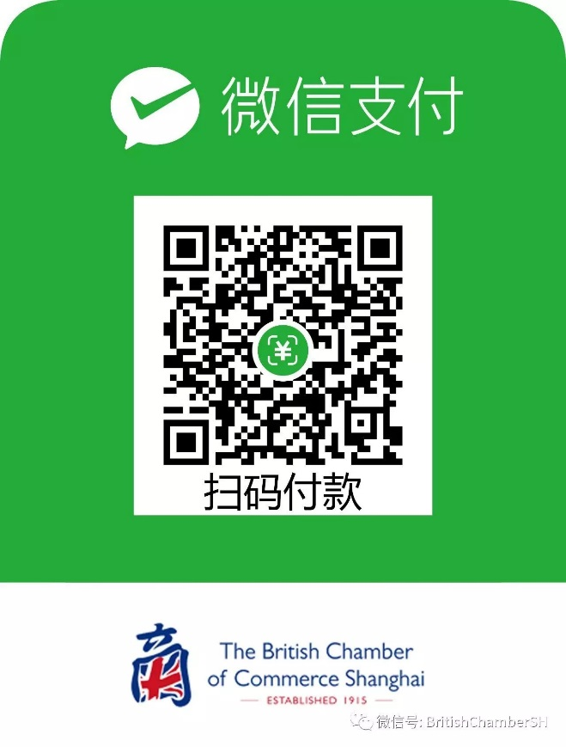
- Please email accounting@britishchambershanghai.cn the screen shot and note who/which company pays for it.

Any questions regarding payment, please feel free to directly contact The British Chamber of Commerce Shanghai’s Finance Department, at 8621－62185022 or via email accounting@britishchambershanghai.cn

[BOOKING TERMS & CONDITIONS]

All bookings
- Payment for bookings must be made within the payment terms in the invoice request or before the event, whichever is soonest. Should payment not be received within the stated time, the booking will automatically be cancelled.
- Payment must be received in full prior to event tickets being issued and confirmed.
- Paid bookings are non-refundable.

Table(s) bookings
- We can only accept one single payment of the full amount.
- The guest / company making the booking is responsible for collection of all payment from other guests on the table(s).

